MEET TAIWAN
Business Events in Surprising Taiwan (BEST) Rewards
Program Guidelines

To promote Taiwan as Asia’s premier destination for MICE, and to encourage multinational firms to choose Taiwan for their corporate meetings and incentive travel, the Taiwan MICE Project Office (MEET TAIWAN), sanctioned by the Bureau of Foreign Trade (BOFT), launched the BOFT's Business Events in Surprising Taiwan (BEST) Rewards Program to provide incentives and support to overseas groups coming to Taiwan for corporate meetings and incentive travel.

For overseas corporate meetings and incentive planners and agencies, BEST Rewards offers a “Partner Package” to promote Taiwan to their clients. The Partner Package offers incentives to planners and agencies that have repetitive confirmed bookings in Taiwan.

- Beneficiary Requirements
  - Qualified activities need to meet all of the following criteria:
    - The corporate meeting or incentive travel is held by an overseas company.
    - The itinerary includes at least one of the following: meetings, incentive travel, training, visits to companies or clients, award ceremony, or team building activities.
    - The group stays a minimum of two (2) consecutive nights in Taiwan.
    - The group consists of at least twenty (20) people.

  - Qualified overseas planners and agencies of corporate meetings and incentive travel (hereinafter referred to as “Planner”) need to meet all of the following criteria to become a“Partner”:
    - The agency must be a legal travel agency, PCO, DMC, or PR firm capable of organizing incentive travel and corporate meetings to Taiwan.
    - The agency must not have false or illegal records locally or abroad.

- Rewards Package
  - For a group divided into batches, the group's combined total number of participants will count as the basis for calculation.

  - Rewards are offered according to group scale and event type. Rewards details follow.
    - Inspection Package
Incentives and support in advance of corporate events
      - Site inspection: Recommend venues and help arrange site inspection visits to meeting and/or banquet venues.
      - Subsidy: Partially subsidize accommodation/flight ticket/dining for the inspection trip. The inspection trip subsidy amount is based on the potential group size.

Potential Group Size  (exclusive of Taiwanese) | Inspection Package Items
20–99 pax | Assistance with Site Inspection Arrangements
100–199 pax | Assistance with Site Inspection Arrangements  Subsidy up to NTD 10,000
200–299 pax | Assistance with Site Inspection Arrangements  Subsidy up to NTD 15,000
300–399 pax | Assistance with Site Inspection Arrangements  Subsidy up to NTD 20,000
400 pax and above | Assistance with Site Inspection Arrangements  Subsidy up to NTD 25,000

    - Group Package
Incentives and support during corporate events
      - A welcome kit gift for each group member
      - VIP souvenirs
      - A welcome banner
      - A letter of greeting from MEET TAIWAN

Group Size  (exclusive of Taiwanese) | Group Package Items
Group Size  (exclusive of Taiwanese) | Welcome Kit Gift | Welcome Letter | Welcome Banner | VIP Souvenirs
20–99 pax | 1 per attendee
100–199 pax | 1 per attendee | 1 per group | 1 per group | 25 per group
200–299 pax | 1 per attendee | 1 per group | 1 per group | 50 per group
300–399 pax | 1 per attendee | 1 per group | 1 per group | 75 per group
400 pax and above | 1 per attendee | 1 per group | 1 per group | 100 per group

    - Partner Package
Partner Package recipients receive incentive rewards that will be valid the following year based on the annual accumulation of attendees at corporate events in Taiwan during the approved application year.

Total Accumulated Annual Attendance  (exclusive of Taiwanese) | Reward for Next Year
20–99 pax | Taiwan Excellence Awarded Product  (valued from NTD5,000 to 10,000)
100–199 pax | Inspection subsidy up to NTD 15,000
200–299 pax | Inspection subsidy up to NTD 20,000
300–399 pax | Inspection subsidy up to NTD 25,000
400 pax and above | One (1) complimentary pass for the SENSE Taiwan Tour

- Application Procedures
  - Either an event owner (overseas corporation) or a Taiwan agent (travel agency, PCO, DMC, or PR firm) may submit an application (hereinafter referred to as “Applicant”).

  - Only confirmed corporate events ending before December 15 are qualified for BEST Rewards. Applications must be submitted before December 10.

  - Submission of documents
    - To apply for an Inspection Package, please submit:
      - Inspection package application form
      - Site inspection request form
      - Applicant company's legal documents (business license or government certification) or public information available from the Economic Division or Taiwan Trade Center of the Applicant’s country.

The Inspection Package is reserved for inspection tours of conference and banquet venues. The completed application and all respective supplementary documents must be submitted at least one (1) month prior to the first day of the inspection trip.

    - To apply for a Group Package, please submit:
      - Group package application form
      - List of participants
      - Itinerary
      - Applicant company's legal documents (business license or government certification) or public information available from the Economic Division or Taiwan Trade Center of the Applicant’s country.

The completed application and all respective supplementary documents must be submitted at least one (1) month prior to the first day of the corporate event.

If items (b) and/or (c) are not confirmed at the time of application submission, the Applicant must provide notification of a confirmed update at least five (5) days prior to the first day of the corporate event.

    - Application for a Partner Package is a two-step process. First, Planners must apply to qualify for the Partner Package. Second, separate Event Forms need to be submitted for each qualifying event to accrue for rewards.

To apply for the Partner Package, the following documents must first be submitted:
      - Partner Package Application Form
      - Planner's legal documents (business license or government certification) or public information available from the Economic Division or Taiwan Trade Center of the Applicant’s country.

For an event to be included in the total accumulation for a Partner Package reward, the following must be submitted:
- Partner Package Upcoming Event Form
- List of participants
- Itinerary

The completed application and all respective supplementary documents must be submitted at least five (5) days prior to the first day of the upcoming corporate event.

  - The BEST Rewards Program budget is limited; therefore once funds are exhausted, applications will no longer be accepted. Applications are processed on a first-come-first-served basis.

  - If requested supplementary documents are not comprehensive or contain errors, Applicants will need to re-submit within the period requested by the Taiwan MICE Project Office (hereinafter referred to as “Project Office”). Further delay may cause the Project Office to consider the application forfeited by the Applicant.

  - All information stated on application forms and supplementary documents must be accurate and true. If not, the Applicant must reimburse the Project Office for all rewards, and future applications submitted by the Applicant will be rejected.

  - The Project Office will notify the Applicant in writing of the final status of the application.

- Conditions
Applicants granted with rewards need to fulfill the following obligations.
- Inspection Package
    - If the inspection tour is cancelled by the Applicant after approval of the application, the reward will be withdrawn.
    - If the event is cancelled by the Applicant after approval of the application, the reward will be withdrawn.
    - Applicants must provide event information to the Project Office for reference.
    - For Applicants granted with an accommodation/flight ticket/dining subsidy:
      - Applicants need to submit materials listed in the table below within two (2) weeks after completion of the inspection tour. If the inspection tour ends between December 1 and December 15, the materials need to be submitted within five (5) days after completion of the inspection tour.
      - If the requested materials are not comprehensive or contain errors, Applicants need to re-submit within a period requested by the Project Office. Further delay may cause the Project Office to reject the subsidy request.

Subsidized Items | Requested Materials for Submission
Flight Ticket | - Copy of approved application form  - E-ticket*  - Receipt issued by an airline or Taiwanese travel agency*  - Boarding pass*  - Passport copy  - Event Result Report
Accommodation | - Copy of approved application form  - Booking list with room price(s) and client signature(s)*  - Receipt issued by a hotel or Taiwanese travel agency*  - Event Result Report
Dining | - Copy of approved application form  - Receipt issued by a restaurant or Taiwanese travel agency*  - Order list with price and client signatures, if dining in a hotel where clients are staying*  - Event Result Report
*Only originals are accepted, unless otherwise stated.

- Group Package
- If the event is cancelled by the Applicant after approval of the application, the reward will be withdrawn.
- Applicants must arrange pick up of rewards such as Welcome Kit Gifts, VIP souvenirs, and welcome banners.
- Applicants need to provide event information to the Project Office for reference.
- Applicants need to submit materials listed in the table below within two (2) weeks after completion of the event. If the event ends between December 1 and December 15, the materials need to be submitted within five (5) days after completion of the event.
- If the requested materials are not comprehensive or contain errors, Applicants need to re-submit within a period requested by the Project Office. Further delay may cause the Project Office to reject the subsidy request.

Requested Materials to Submit
- Copy of approved application form
- Event Result Report

- Partner Package
The Project Office will calculate the accumulative attendance of all Partner-qualified events. The results and rewards will be announced during the first quarter of the upcoming year.

- Other
Modifications or additions to the current regulations are subject to the discretion of the relevant authorities, if needed, and without public announcement.
- Contacts
For further information or applications, please contact Ms. Chloe Chiu
(Tel.: +886-2-2725-5200 ext. 3534 / Email: hyc@taitra.org.tw)

- Appendices

Appendix 1—Inspection Package Application Form
Appendix 2—Site Inspection Request Form
Appendix 3—Group Package Application Form
Appendix 4—Welcome Kit Gift List
Appendix 5—VIP Souvenirs List
Appendix 6—Event Result Report
Appendix 7—Partner Package Application Form
Appendix 8—Partner Package Upcoming Event Form
MEET TAIWAN
Business Events in Surprising Taiwan (BEST) Rewards Program
Inspection Package Application Form

Basic Information
Event Name
Event Owner
Event Date | From ____________________________ (DD/MM/YY)  To ____________________________ (DD/MM/YY)
Expected Event Attendance | __________ person(s) per group (exclusive of Taiwanese)  Nationality(ies): _______________________________
Venue
Inspection Trip Date | From ____________________________ (DD/MM/YY)  To ____________________________ (DD/MM/YY)
Inspection Trip Attendees | __________ person(s)
Contact Person | Name: ______________________________  Position: ______________________________  Company: ______________________________  Address: ______________________________  Tel.: ______________________________  E-mail: ______________________________
Group Size | Inspection Package Items  (Please mark requested items.)
20–99 pax | ◻ Assistance with Site Inspection Arrangements
100–199 pax | ◻ Assistance with Site Inspection Arrangements  ◻ Subsidy up to NTD 10,000
200–299 pax | ◻ Assistance with Site Inspection Arrangements  ◻ Subsidy up to NTD 15,000
300–399 pax | ◻ Assistance with Site Inspection Arrangements  ◻ Subsidy up to NTD 20,000
400 pax and above | ◻ Assistance with Site Inspection Arrangements  ◻ Subsidy up to NTD 25,000
- I agree that all information stated on the application forms and supplementary documents is accurate and true. If not, the Applicant must reimburse the Project Office for all rewards, and future applications submitted by the Applicant will be rejected.
- I agree to submit all requested documents stated in “IV. Conditions” of the BEST Rewards Program Guidelines within 2 weeks after completion of the event.
- I agree to provide event information to the Project Office for reference.
Please send this form, Appendix 2, and copies of the Applicant company's legal documents and/or public information available from the Economic Division or Taiwan Trade Center of the Applicant's country to Ms. Lena Chang at lenachang@taitra.org.tw

Signature _______________________________

FOR OFFICIAL USE ONLY
Approved Rewards | Project Code
Signature | No.
Signature | Result  □ Approved  □ Rejected

MEET TAIWAN
Business Events in Surprising Taiwan (BEST) Rewards Program
Site Inspection Request Form

Basic Information
Inspection Trip Date | From ____________________________ (DD/MM/YY)  To ____________________________ (DD/MM/YY)
Inspection Trip Attendee(s) | __________ person(s)
List of Site Inspection Attendees
Name | Position | Organization/Company
Site Inspection Itinerary
Date | Venue | Intended Venue Usage
- I agree that all information stated on application forms and supplementary documents is accurate and true. If not, the Applicant must reimburse all rewards to the Project Office, and future applications submitted by the Applicant will be rejected.

MEET TAIWAN
Business Events in Surprising Taiwan (BEST) Rewards Program
Group Package Application Form

Basic Information
Event Name
Event Owner
Event Date |  | From ____________________________ (DD/MM/YY)  To ____________________________ (DD/MM/YY)
Expected Event Attendance |  | __________ person(s) per group (exclusive of Taiwanese)  Nationality(ies):______________________________
Venue
Contact Person |  | Name: ______________________________  Position: ______________________________  Company: ______________________________  Address: ______________________________  Tel.: ______________________________  E-mail: ______________________________
Group Size | Group Package Items  (Please mark requested items.)
20–99  pax | Welcome Kit Gift | Limited to one (1) per attendee. Organizer may choose an assortment. Indicate quantity per item in its following blank.  ◻ Postcard _____ ◻ Screen cleaner sticker _____  ◻ Paper bookmark _____ ◻ Suitcase belt _____  ◻ Pocket memo pad _____
100–199  pax | Welcome Kit Gift | Limited to one (1) per attendee. Organizer may choose an assortment. Indicate quantity per item in its following blank.  ◻ Postcard _____ ◻ Screen cleaner sticker _____  ◻ Paper bookmark _____ ◻ Suitcase belt _____  ◻ Pocket memo pad _____
100–199  pax | Welcome Letter | ◻ in English
100–199  pax | Welcome Banner | ◻ in English
100–199  pax | VIP Souvenir | Maximum of 25 VIP souvenirs per group. Organizer may choose an assortment. Indicate quantity per item in its following blank.  ◻ Passport wallet ____ ◻ MEET TAIWAN USB flash ____  ◻ Taiwan notebook ____ ◻ Absorbent coaster _____
200–299  pax | Welcome Kit Gift | Limited to one (1) per attendee. Organizer may choose an assortment. Indicate quantity per item in its following blank.  ◻ Postcard _____ ◻ Screen cleaner sticker _____  ◻ Paper bookmark _____ ◻ Suitcase belt _____  ◻ Pocket memo pad _____
200–299  pax | Welcome Letter | ◻ in English
200–299  pax | Welcome Banner | ◻ in English
200–299  pax | VIP Souvenir | Maximum of 50 VIP souvenirs per group. Organizer may choose an assortment. Indicate quantity per item in its following blank.  ◻ Passport wallet ____ ◻ MEET TAIWAN USB flash ____  ◻ Taiwan notebook ____ ◻ Absorbent coaster _____
300–399  pax | Welcome Kit Gift | Limited to one (1) per attendee. Organizer may choose an assortment. Indicate quantity per item in its following blank.  ◻ Postcard _____ ◻ Screen cleaner sticker _____  ◻ Paper bookmark _____ ◻ Suitcase belt _____  ◻ Pocket memo pad _____
300–399  pax | Welcome Letter | ◻ in English
300–399  pax | Welcome Banner | ◻ in English
300–399  pax | VIP Souvenir | Maximum of 75 VIP souvenirs per group. Organizer may choose an assortment. Indicate quantity per item in its following blank.  ◻ Passport wallet _____ ◻ MEET TAIWAN USB flash ____  ◻ Taiwan notebook ____ ◻ Absorbent coaster _____
400 pax and above | Welcome Kit Gift | Limited to one (1) per attendee. Organizer may choose an assortment. Indicate quantity per item in its following blank.  ◻ Postcard _____ ◻ Screen cleaner sticker _____  ◻ Paper bookmark _____ ◻ Suitcase belt _____  ◻ Pocket memo pad _____
400 pax and above | Welcome Letter | ◻ in English
400 pax and above | Welcome Banner | ◻ in English
400 pax and above | VIP Souvenir | Maximum of 100 VIP souvenirs per group. Organizer may choose an assortment. Indicate quantity per item in its following blank.  ◻ Passport wallet ____ ◻ MEET TAIWAN USB flash ____  ◻ Taiwan notebook ____ ◻ Absorbent coaster ____
- I agree that all information stated on the application forms and supplementary documents is accurate and true. If not, the Applicant must reimburse the Project Office for all rewards, and future applications submitted by the Applicant will be rejected.
- I agree to submit all requested documents stated in “IV. Conditions” of the BEST Rewards Program Guidelines within 2 weeks after completion of the event.
- I agree to provide event information to the Project Office for reference.
Please send this form, the list of participants, the itinerary, and copies of the Applicant company's legal documents and/or public information available from the Economic Division or Taiwan Trade Center of the Applicant's country to Ms. Lena Chang at lenachang@taitra.org.tw

Signature _______________________________

FOR OFFICIAL USE ONLY
Approved Rewards | Project Code
Signature | No.
Signature | Result  □ Approved  □ Rejected

MEET TAIWAN
Business Events in Surprising Taiwan (BEST) Rewards Program
Welcome Kit Gift List
A Welcome Kit Gift contains a MEET TAIWAN DM and a welcome gift. MEET TAIWAN offers four (4) different welcome gifts to choose from, as shown below.
Please indicate on the Group Package Application Form the corresponding letter/item of your selection for a Welcome Kit gift.
Welcome Gift Options
 | 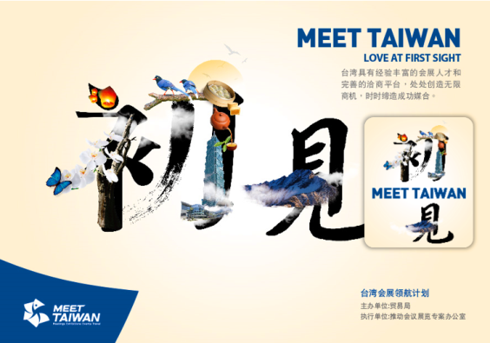
A. Postcard | B. Screen cleaner sticker
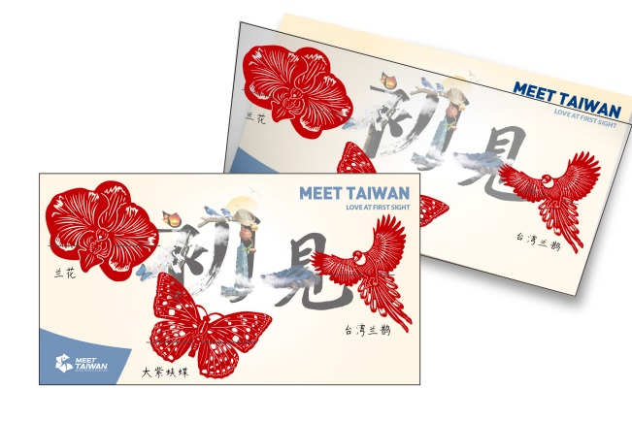 |   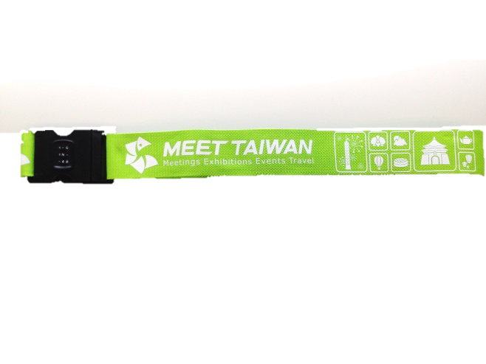
  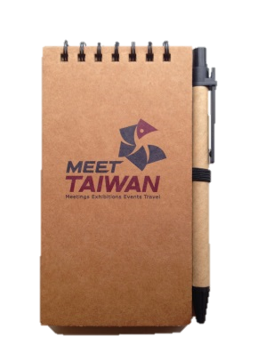  C. Paper bookmark | D. Suitcase belt
E. Pocket Memo Pad
Notes:
- Photos are for reference only; actual items may vary in color and/or design.
- If the item requested is out of stock, please choose another item.
- MEET TAIWAN will update items from time to time.
MEET TAIWAN
Business Events in Surprising Taiwan (BEST) Rewards Program
VIP Souvenir List

MEET TAIWAN offers four (4) different VIP souvenirs to choose from, as shown below.

Please indicate on the Group Package Application Form the corresponding letter/item of your selection for VIP souvenirs.

VIP Souvenirs Options
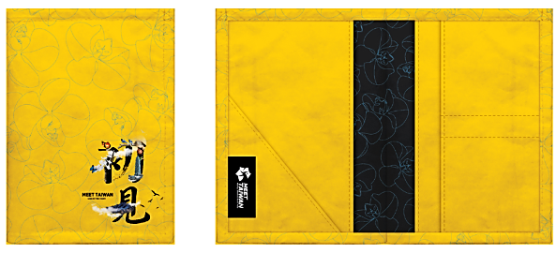 | 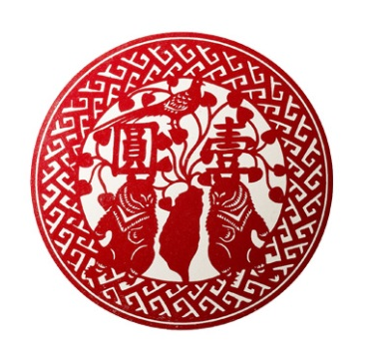
A. Passport Wallet | B. Absorbent Coaster
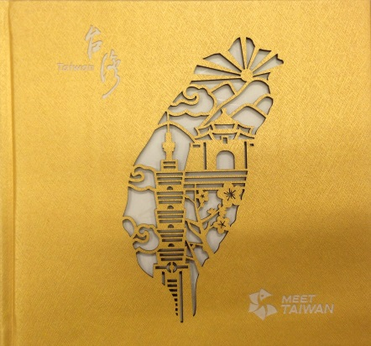 | 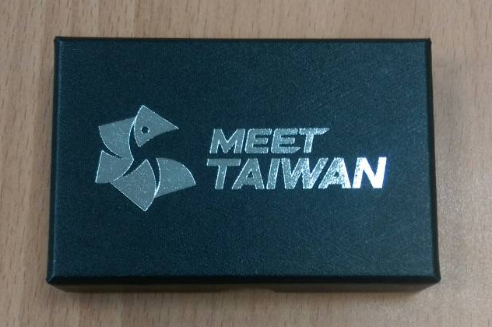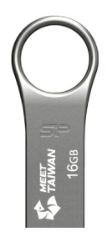
C. Taiwan Notebook | D. MEET TAIWAN 16GB USB Flash

Notes:
- Photos are for reference only; actual items may vary in color and/or design.
- If the item requested is out of stock, please choose another item.
- MEET TAIWAN will update items from time to time.

MEET TAIWAN
Business Events in Surprising Taiwan (BEST) Rewards Program
Event Result Report
Basic Information
Event Name
Actual Event Date* | From ____________________________ (DD/MM/YY)  To ____________________________ (DD/MM/YY)
Actual Event Attendance* | __________ person(s) per group (exclusive of Taiwanese)  Nationality(ies):______________________________
*For Inspection Package, please fill in the blanks with actual date and attendance of the inspection tour.
Please provide two (2) event photos
Please insert photo here. |  | Photo description (100 words or less)
Please insert photo here. |  | Photo description (100 words or less)
- I agree that all information stated on report forms and supplementary documents is accurate and true. If not, the Applicant must reimburse all rewards to the Project Office, and future applications submitted by the Applicant will be rejected.
- I agree that photos together with descriptions above can be used for purposes of MEET TAIWAN promotion.
- Please send this form and a copy of the approved application form to Ms. Lena Chang at lenachang@taitra.org.tw
- If reimbursement is required, please submit the requested documents stated in “IV. Conditions” of the BEST Rewards Program Guidelines and provide account information on the following page.

Account Information
Account Name: | Swift Code:
Account Number: | IBAN:
Bank Name: | Accepted Currency:
Bank Address:
- I agree to the following transaction conditions:
- Exchange rate is based on the transaction date rate.
- Accepted currency is limited to currencies the Taiwan Bank can transfer.

MEET TAIWAN
Business Events in Surprising Taiwan (BEST) Rewards Program
Partner Package Application Form
Basic Information
Company Name
Company Address
Contact Person |  | Name: ________________________________  Position: ________________________________  Tel.: ________________________________  E-mail: ________________________________
Main Service  (multiple choice) |  | □ Outbound groups □ Outbound FIT □ Flight ticket  □ Venue □ Overseas corporate meetings  □ Overseas incentive travel □ Hotel  □ Other:________________________________
Information of Past Events in Taiwan
No. | Event Name |  | Event Date  (DD/MM/YY) | Event Attendance  (exclusive of Taiwanese)
From____________
To ____________
From____________
To ____________
From____________
To ____________
- I agree that all information stated on the application forms and supplementary documents is accurate and true. If not, future applications submitted by the Applicant will be rejected.
- I agree to provide event information to the Project Office for reference.
Please send this form and copies of the Applicant company's legal documents and/or public information available from the Economic Division or Taiwan Trade Center of the Applicant's country to Ms. Lena Chang at lenachang@taitra.org.tw

Signature _______________________________

FOR OFFICIAL USE ONLY
Signature | No.
Signature | Result  □ Approved  □ Rejected

MEET TAIWAN
Business Events in Surprising Taiwan (BEST) Rewards Program
Partner Package Upcoming Event Form

Basic Information
Company Name
Contact Person | Name: ________________________________  Position: ________________________________  Tel.: ________________________________  E-mail: ________________________________
Information of Upcoming Event
Event Name |  | Event Date  (DD/MM/YY) | Event Attendance  (exclusive of Taiwanese)
From __________
To __________
- I agree that all information stated on the application forms and supplementary documents is accurate and true. If not, the Applicant must reimburse the Project Office for all rewards, and future applications submitted by the Applicant will be rejected.
- I agree to provide event information to the Project Office for reference.
Please send this form, the list of participants, and the itinerary to Ms. Lena Chang at lenachang@taitra.org.tw

Signature _______________________________

FOR OFFICIAL USE ONLY
Signature | No.
Signature | Result  □ Approved  □ Rejected

